==================================================

Running Genetic Algorithm...

==================================================

==================================================

=== GENETIC ALGORITHM OPTIMIZATION ===

==================================================

[Initialization]

- Population size: 30

- Generations: 20

- Crossover rate: 80%

- Mutation rate: 20%

- Search space: 50 features

- Target: Minimize MSE using CatBoost

==================================================

=== OPTIMIZATION RESULTS ===

==================================================

▶ Best MSE achieved: 0.143812

▶ Time elapsed: 594.08 seconds

▶ Features selected: 28/50 (44.0% reduction)

▶ Selected features:

1. CreditScore

2. AnnualIncome

3. Age

4. NumberOfDependents

5. EducationLevel

6. HomeOwnershipStatus

7. NumberOfCreditInquiries

8. DebtToIncomeRatio

9. BankruptcyHistory

10. LoanPurpose

11. InterestRate

12. PaymentHistory

13. SavingsAccountBalance

14. InvestmentAccountBalance

15. RetirementAccountBalance

16. TotalAssets

17. LengthOfCreditHistory

18. PersonalLoanBalance

19. HealthInsuranceStatus

20. CarInsuranceStatus

21. OtherInsurancePolicies

22. JobTenure

23. MonthlySavings

24. AnnualBonuses

25. AnnualExpenses

26. MonthlyFoodCosts

27. MonthlyHealthcareCosts

28. MonthlyEntertainmentCosts

▶ Convergence progress:

- Initial MSE: 0.1438

- Final MSE: 0.1438

- Improvement: 0.0%

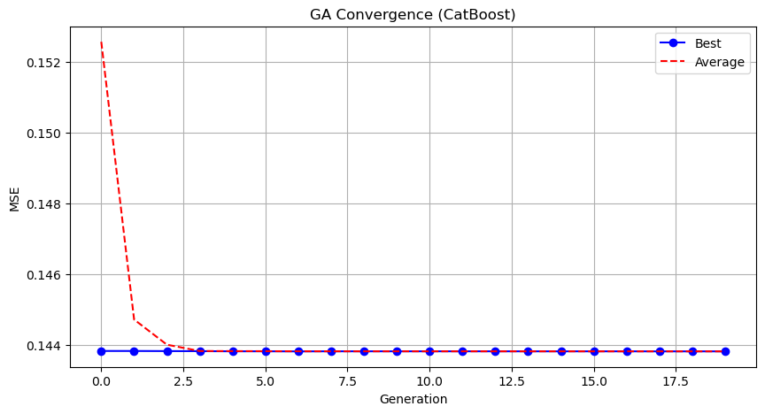

Genetic Algorithm completed successfully with MSE: 0.1438

==================================================

Running Particle Swarm Optimization...

==================================================

==================================================

=== PARTICLE SWARM OPTIMIZATION ===

==================================================

[Initialization]

- Swarm size: 30 particles

- Iterations: 20

- Cognitive weight: 0.5

- Social weight: 0.5

- Inertia weight: 0.5

- Search space: 50 features

- Target: Minimize MSE using CatBoost

==================================================

=== OPTIMIZATION RESULTS ===

==================================================

▶ Best MSE achieved: 0.143822

▶ Time elapsed: 89.41 seconds

▶ Features selected: 24/50 (52.0% reduction)

▶ Selected features (with weights):

1. CreditScore (weight: 0.538)

2. AnnualIncome (weight: 0.563)

3. LoanAmount (weight: 0.522)

4. LoanDuration (weight: 0.564)

5. EmploymentStatus (weight: 0.826)

6. MaritalStatus (weight: 0.549)

7. HomeOwnershipStatus (weight: 0.628)

8. NumberOfCreditInquiries (weight: 0.743)

9. LoanPurpose (weight: 0.577)

10. PreviousLoanDefaults (weight: 0.536)

11. InterestRate (weight: 0.700)

12. PaymentHistory (weight: 0.547)

13. InvestmentAccountBalance (weight: 0.697)

14. EmergencyFundBalance (weight: 0.684)

15. RentPayments (weight: 0.561)

16. PersonalLoanBalance (weight: 1.000)

17. UtilityBillsPaymentHistory (weight: 0.891)

18. HealthInsuranceStatus (weight: 0.649)

19. LifeInsuranceStatus (weight: 0.836)

20. HomeInsuranceStatus (weight: 0.514)

21. OtherInsurancePolicies (weight: 0.550)

22. EmployerType (weight: 0.815)

23. MonthlyHousingCosts (weight: 0.545)

24. MonthlyHealthcareCosts (weight: 0.819)

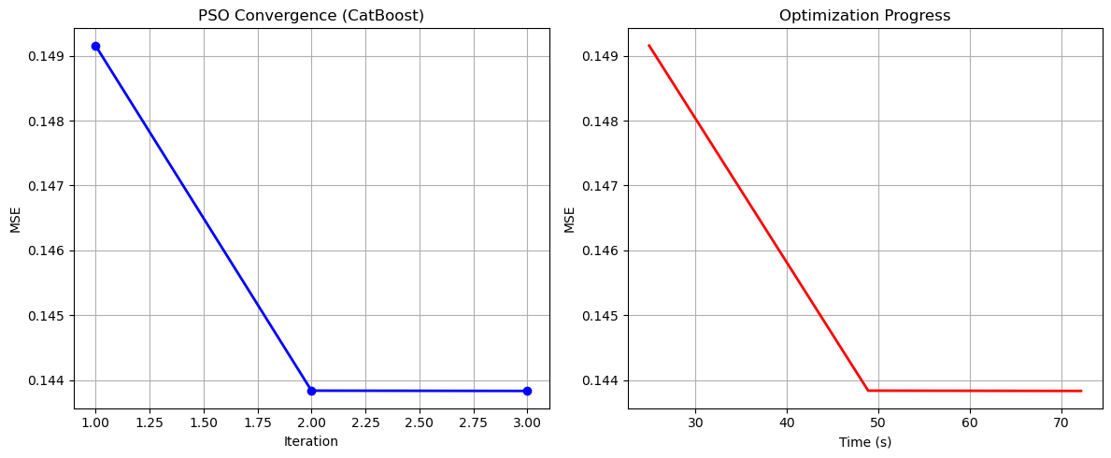

Particle Swarm Optimization completed successfully with MSE: 0.1438

==================================================

Running Whale Optimization...

==================================================

==================================================

=== WHALE OPTIMIZATION ALGORITHM ===

==================================================

[Initialization]

- Population: 30 whales

- Max iterations: 20

- Spiral coefficient (b): 1.0

- Search space: 50 features

- Target: Minimize MSE using CatBoost

[Optimization Progress]

Iter 20/20 | Best MSE: 0.143822

==================================================

=== OPTIMIZATION RESULTS ===

==================================================

▶ Best MSE achieved: 0.143822

▶ Time elapsed: 611.27 seconds

▶ Features selected: 47/50 (6.0% reduction)

▶ Selected features:

1. CreditScore

2. AnnualIncome

3. LoanAmount

4. LoanDuration

5. Age

6. EmploymentStatus

7. MaritalStatus

8. NumberOfDependents

9. EducationLevel

10. HomeOwnershipStatus

11. MonthlyDebtPayments

12. CreditCardUtilizationRate

13. NumberOfOpenCreditLines

14. DebtToIncomeRatio

15. BankruptcyHistory

16. LoanPurpose

17. PreviousLoanDefaults

18. InterestRate

19. PaymentHistory

20. SavingsAccountBalance

21. CheckingAccountBalance

22. InvestmentAccountBalance

23. RetirementAccountBalance

24. EmergencyFundBalance

25. TotalAssets

26. TotalLiabilities

27. NetWorth

28. LengthOfCreditHistory

29. MortgageBalance

30. RentPayments

31. AutoLoanBalance

32. PersonalLoanBalance

33. StudentLoanBalance

34. UtilityBillsPaymentHistory

35. HealthInsuranceStatus

36. LifeInsuranceStatus

37. HomeInsuranceStatus

38. OtherInsurancePolicies

39. EmployerType

40. JobTenure

41. MonthlySavings

42. AnnualBonuses

43. MonthlyHousingCosts

44. MonthlyTransportationCosts

45. MonthlyFoodCosts

46. MonthlyHealthcareCosts

47. MonthlyEntertainmentCosts

▶ Convergence progress:

- Initial MSE: 0.1492

- Final MSE: 0.1438

- Improvement: 3.6%

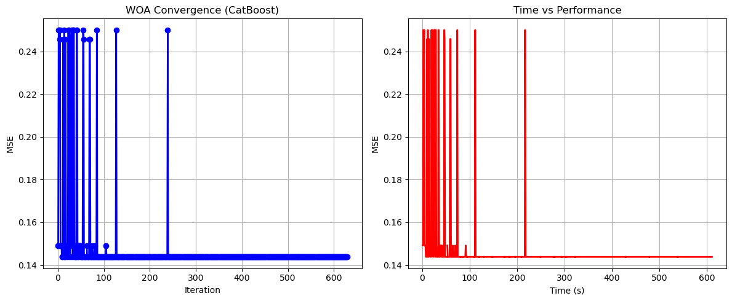

Whale Optimization completed successfully with MSE: 0.1438

==================================================

Running Squid Game Optimizer...

==================================================

==================================================

=== SQUID GAME OPTIMIZER (SGO) ===

==================================================

[Initialization]

- Players: 30 (15 offensive, 15 defensive)

- Max games: 20

- Search space: 50 features

- Target: Minimize MSE using XGBoost

==================================================

=== OPTIMIZATION RESULTS ===

==================================================

▶ Best MSE achieved: 0.143818

▶ Time elapsed: 536.65 seconds

▶ Features selected: 26/50 (48.0% reduction)

▶ Selected features:

1. CreditScore

2. AnnualIncome

3. LoanDuration

4. HomeOwnershipStatus

5. NumberOfOpenCreditLines

6. NumberOfCreditInquiries

7. DebtToIncomeRatio

8. LoanPurpose

9. PreviousLoanDefaults

10. CheckingAccountBalance

11. RetirementAccountBalance

12. EmergencyFundBalance

13. RentPayments

14. PersonalLoanBalance

15. UtilityBillsPaymentHistory

16. HealthInsuranceStatus

17. LifeInsuranceStatus

18. CarInsuranceStatus

19. HomeInsuranceStatus

20. EmployerType

21. MonthlySavings

22. AnnualBonuses

23. AnnualExpenses

24. MonthlyTransportationCosts

25. MonthlyFoodCosts

26. MonthlyEntertainmentCosts

▶ Convergence progress:

- Initial MSE: 0.1438

- Final MSE: 0.1438

- Improvement: 0.0%

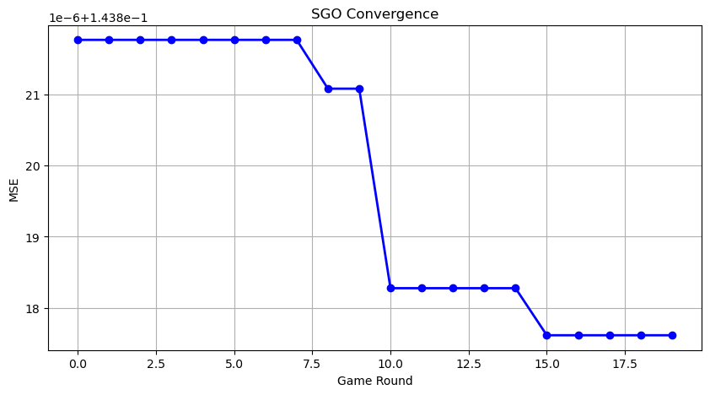

Squid Game Optimizer completed successfully with MSE: 0.1438

==================================================

Running PSH-Hyptrite...

==================================================

==================================================

=== PSH-HYPTRITE OPTIMIZATION ===

==================================================

[Initialization]

- Search points: 30

- Max iterations: 20

- Initial radius: 0.5 (adaptive)

- Hypersphere samples: 3 per point

- Search space: 50 features

- Target: Minimize MSE using XGBoost

[Optimization Progress]

Iter 20/20 | Best MSE: 0.143813 | Radius: 0.0250

==================================================

=== OPTIMIZATION RESULTS ===

==================================================

▶ Best MSE achieved: 0.143813

▶ Time elapsed: 1723.02 seconds

▶ Features selected: 28/50 (44.0% reduction)

▶ Selected features (with weights):

1. CreditScore (weight: 0.641)

2. AnnualIncome (weight: 0.511)

3. LoanDuration (weight: 0.941)

4. HomeOwnershipStatus (weight: 0.558)

5. MonthlyDebtPayments (weight: 0.524)

6. CreditCardUtilizationRate (weight: 0.892)

7. NumberOfCreditInquiries (weight: 0.566)

8. DebtToIncomeRatio (weight: 0.808)

9. LoanPurpose (weight: 0.964)

10. PreviousLoanDefaults (weight: 0.733)

11. InterestRate (weight: 0.794)

12. PaymentHistory (weight: 0.888)

13. SavingsAccountBalance (weight: 0.881)

14. CheckingAccountBalance (weight: 0.521)

15. InvestmentAccountBalance (weight: 0.710)

16. EmergencyFundBalance (weight: 0.548)

17. MortgageBalance (weight: 0.750)

18. HealthInsuranceStatus (weight: 0.692)

19. LifeInsuranceStatus (weight: 0.889)

20. CarInsuranceStatus (weight: 0.550)

21. HomeInsuranceStatus (weight: 0.925)

22. OtherInsurancePolicies (weight: 0.865)

23. EmployerType (weight: 0.523)

24. MonthlySavings (weight: 0.679)

25. AnnualBonuses (weight: 0.805)

26. MonthlyTransportationCosts (weight: 0.587)

27. MonthlyFoodCosts (weight: 0.805)

28. MonthlyEntertainmentCosts (weight: 0.862)

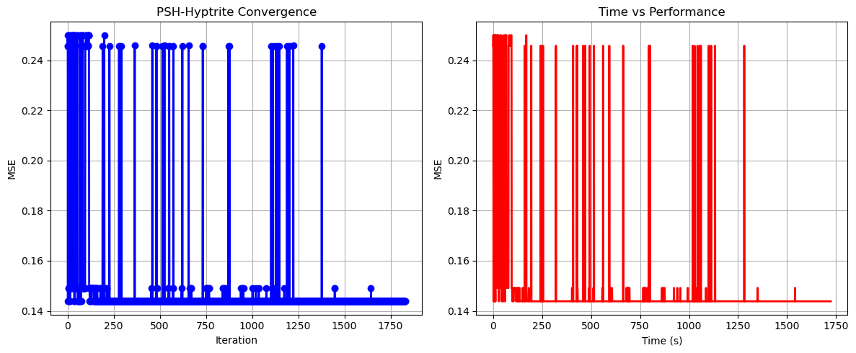

PSH-Hyptrite completed successfully with MSE: 0.1438

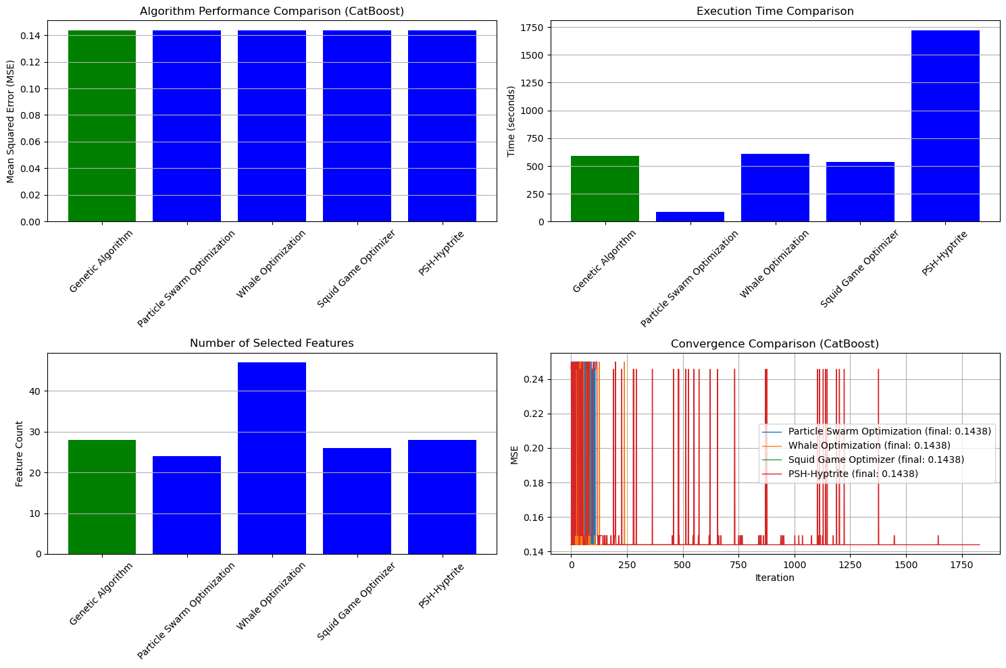

==================================================

FINAL RESULTS SUMMARY (Using CatBoost)

==================================================

🏆 Best Algorithm: Genetic Algorithm

📉 Best MSE Achieved: 0.143812

⏱️ Execution Time: 594.08 seconds

🔢 Features Selected: 28

Selected Features:

1. CreditScore

2. AnnualIncome

3. Age

4. NumberOfDependents

5. EducationLevel

6. HomeOwnershipStatus

7. NumberOfCreditInquiries

8. DebtToIncomeRatio

9. BankruptcyHistory

10. LoanPurpose

11. InterestRate

12. PaymentHistory

13. SavingsAccountBalance

14. InvestmentAccountBalance

15. RetirementAccountBalance

16. TotalAssets

17. LengthOfCreditHistory

18. PersonalLoanBalance

19. HealthInsuranceStatus

20. CarInsuranceStatus

21. OtherInsurancePolicies

22. JobTenure

23. MonthlySavings

24. AnnualBonuses

25. AnnualExpenses

26. MonthlyFoodCosts

27. MonthlyHealthcareCosts

28. MonthlyEntertainmentCosts